Protein Structural Analysis of BRCA1 Using PDB

Aastha Mani
B.Tech. Biotechnology, Graphic Era University
Independent Learning Project

Abstract
The three-dimensional structure of proteins plays a crucial role in understanding their biological functions. In this study, the structural properties of the BRCA1 protein from Homo sapiens were analyzed using the Protein Data Bank (PDB). The selected structure (PDB ID: 3C0J) represents the BRCT domain of BRCA1 in complex with a phosphorylated peptide. Structural analysis revealed the presence of alpha helices, beta sheets, and a well-defined binding pocket. The interaction between the BRCA1 domain and peptide highlights its role in DNA repair mechanisms. This study demonstrates the importance of structural databases in understanding protein function at the molecular level.

Introduction
Bioinformatics databases not only provide sequence and functional information but also offer insights into the three-dimensional structure of proteins. Structural biology helps in understanding how proteins interact with other molecules and perform their biological roles.
The Protein Data Bank (PDB) is a widely used database that stores experimentally determined 3D structures of proteins and nucleic acids. Structural analysis helps in identifying functional domains, binding sites, and molecular interactions.
The BRCA1 protein is a tumor suppressor involved in DNA repair. While sequence and functional data provide important information, structural analysis helps visualize how BRCA1 interacts with other proteins during DNA damage response.
This study focuses on analyzing the 3D structure of the BRCA1 protein using the PDB database.

Learning Objective
The objective of this study was to gain practical experience in analyzing protein structures using structural databases and visualization tools. This activity helped in understanding the relationship between protein structure and function.

Materials and Methods
Protein data used in this study was obtained from the PDB. The protein selected for analysis was:
- Protein: Breast cancer type 1 susceptibility protein
- Organism: Homo sapiens
- PDB ID: 3C0J

Workflow of the Analysis
- Search for BRCA1 structure in the PDB database
- Select the appropriate structure (3C0J)
- Visualize the structure using the 3D viewer
- Analyze secondary structure (helices and sheets)
- Identify binding site and ligand interaction
- Document observations and screenshots

Results
The structural analysis of the BRCA1 protein using the Protein Data Bank provided detailed insights into its three-dimensional organization and interaction properties. The selected structure (PDB ID: 3C0J) represents the BRCT domain of the BRCA1 protein in complex with a phosphorylated peptide.
The ribbon representation of the structure shows that the BRCT domain is composed of alpha helices and beta sheets arranged in a compact and stable conformation. These secondary structural elements contribute to the proper folding and functional integrity of the protein.
The binding site analysis revealed that the phosphorylated peptide interacts specifically within a defined pocket of the BRCT domain. The interaction is stabilized by hydrogen bonds and other non-covalent interactions between amino acid residues of the protein and the ligand.
The molecular surface representation further highlights the presence of a distinct binding cavity, confirming the structural basis for protein–protein interaction. These observations demonstrate that the BRCT domain plays a crucial role in recognizing phosphorylated proteins involved in DNA damage response pathways.

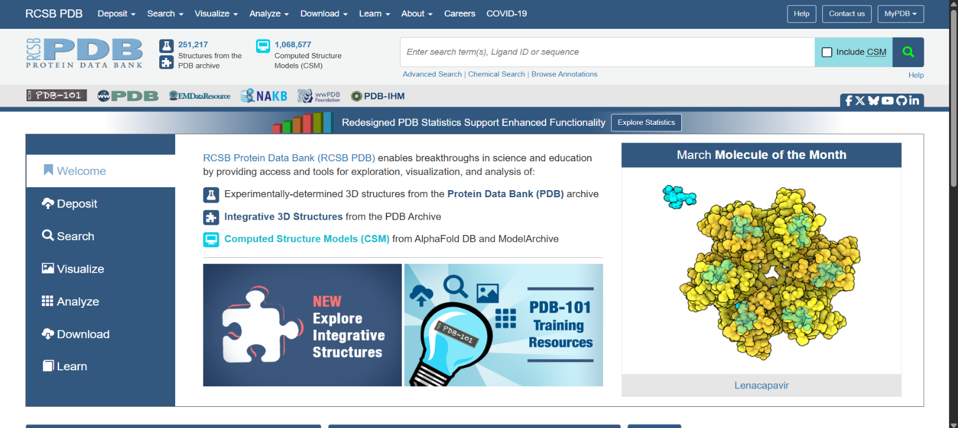
Figure 1:Homepage of the RCSB Protein Data Bank showing database overview, navigation tools, and access to experimentally determined and computed protein structures.
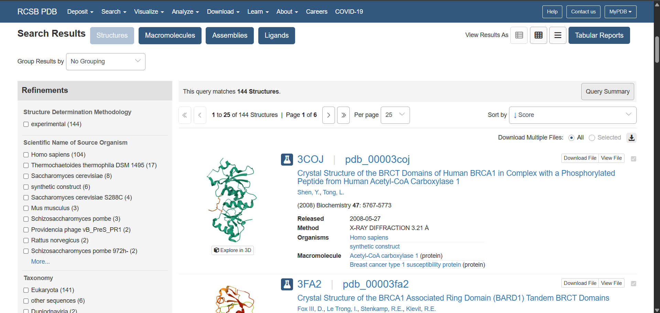
Figure 2:Search results from the RCSB PDB database displaying multiple BRCA1-related structures, including the selected structure (PDB ID: 3C0J) along with its experimental details.
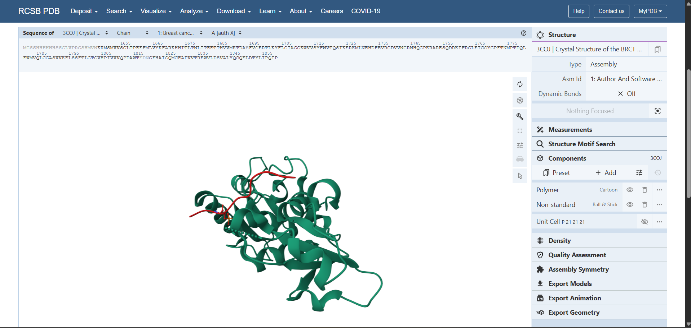Figure 3:
Ribbon representation of the BRCA1 BRCT domain illustrating the overall three-dimensional folding and secondary structural elements such as alpha helices and loops.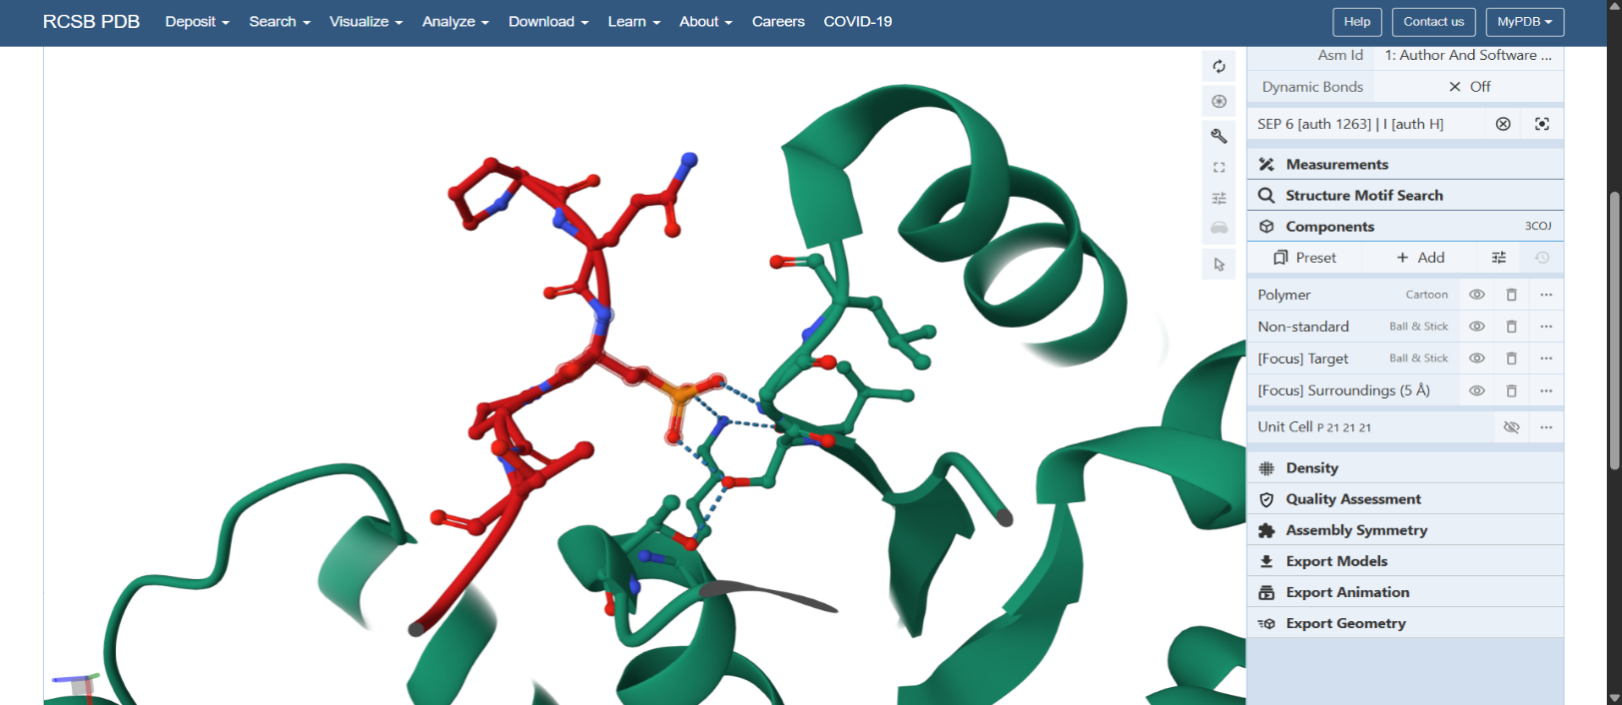Figure 4:
Three-dimensional structural visualization of the BRCA1 protein highlighting the peptide ligand (shown in red) interacting with the protein domain.
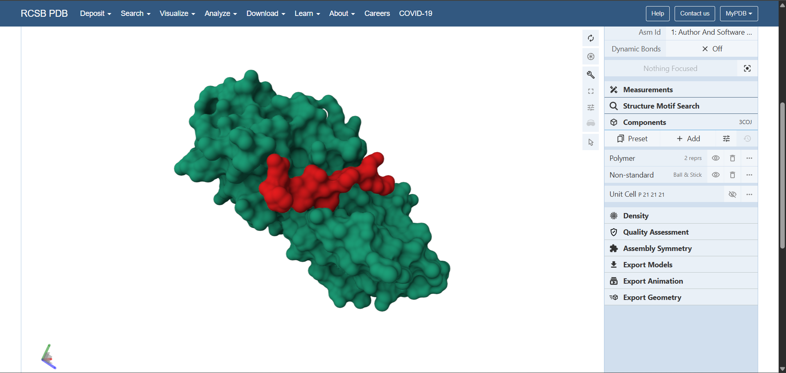Figure 5:
Molecular surface representation of the BRCA1 protein highlighting the ligand-binding pocket (in red), indicating the active interaction region.

Discussion
The results obtained from the structural analysis of the BRCA1 protein provide important insights into its functional role in the cell. The presence of well-defined secondary structural elements such as alpha helices and beta sheets indicates a stable protein structure necessary for its biological activity.
The identification of a specific binding pocket and its interaction with a phosphorylated peptide highlights the functional significance of the BRCT domain. This domain is known to recognize and bind phosphorylated proteins, which are essential components of DNA repair mechanisms.
The structural findings complement the functional information obtained from protein databases such as UniProt, where BRCA1 is described as a tumor suppressor protein involved in maintaining genomic stability. By combining structural and functional data, a better understanding of the protein’s role in DNA repair and cancer prevention is achieved.
Thus, the study demonstrates the importance of integrating structural bioinformatics with sequence-based analysis to fully understand protein function.

Limitations of the Study
Although the structural analysis of the BRCA1 protein using the PDB database provided valuable insights, certain limitations must be considered.
Firstly, the structure analyzed (3C0J) represents only a specific domain (BRCT domain) of the BRCA1 protein and not the full-length protein. Due to the large size and complexity of BRCA1, complete structural information is not available.
Secondly, the study is entirely based on data obtained from biological databases and does not involve experimental validation. The accuracy of the analysis depends on the quality of the available structural data.
Thirdly, the analysis focuses only on structural visualization and basic interaction analysis. Advanced techniques such as molecular docking, dynamics simulation, or mutation analysis were not included.
Despite these limitations, the study provides a clear understanding of the structural features and functional significance of the BRCA1 protein.

Future Scope
The present study provides a basic understanding of protein structural analysis using the Protein Data Bank. However, several advanced analyses can be carried out in the future to gain deeper insights into the BRCA1 protein.
Future work may include comparative structural analysis of BRCA1 domains across different species to study evolutionary conservation. Molecular docking studies can be performed to analyze how different ligands interact with the BRCT domain.
Further research may involve studying the impact of mutations in the BRCA1 protein structure, which can help in understanding the molecular basis of cancer development. Protein–protein interaction studies and computational modeling can also be used to explore the role of BRCA1 in DNA repair pathways.
Overall, the integration of advanced bioinformatics tools and computational methods can provide a more comprehensive understanding of the structure and function of the BRCA1 protein.

Conclusion
This study highlights the importance of structural databases in understanding protein function. The BRCA1 BRCT domain structure reveals key features such as secondary structure elements and a binding pocket responsible for protein interactions. The integration of sequence, functional, and structural data provides a comprehensive understanding of the protein’s role in DNA repair and cancer biology.

References
- Protein Data Bank
- UniProt Consortium
- National Center for Biotechnology Information (NCBI)
- Altschul SF et al. Basic Local Alignment Search Tool (BLAST)
- Structural Biology Resources (RCSB PDB)

